-- James Gray, CIS 417 Assignment #8

-- DDL statements to create and populate tables

-- SQL Server 2012

CREATE TABLE Starship

-- Starship contains starship details

(starshipID SMALLINT NOT NULL,

starshipName VARCHAR (20) NOT NULL,

crewSize SMALLINT NOT NULL,

shipClass VARCHAR (20) NOT NULL,

launchStarDate SMALLINT NOT NULL,

CONSTRAINT pk_starshipID PRIMARY KEY (starshipID)

);

CREATE TABLE Planet

-- Planet contains planet details

(planetID SMALLINT NOT NULL,

planetName VARCHAR (20) NOT NULL,

radius SMALLINT NOT NULL,

atmosphere VARCHAR (20) NOT NULL,

CONSTRAINT pk_planetID PRIMARY KEY (planetID)

);

CREATE TABLE PlanetVisit

-- PlanetVisit contains the details of starships that visit planets

(planetID SMALLINT NOT NULL,

starshipID SMALLINT NOT NULL,

arrivalStarDate SMALLINT NOT NULL,

departureStarDate SMALLINT NOT NULL,

CONSTRAINT pk_planetVisit PRIMARY KEY (planetID, starshipID, arrivalStarDate),

CONSTRAINT fk_planetVisit_planetID FOREIGN KEY (planetID) REFERENCES Planet (planetID),

CONSTRAINT fk_planetVisit_starshipID FOREIGN KEY (starshipID) REFERENCES Starship (starshipID)

);

-- populate starship table

INSERT INTO Starship (starshipID, starshipName, crewSize, shipClass, launchStarDate) VALUES ('351','Stingray','200','StellarIV', '21450');

INSERT INTO Starship (starshipID, starshipName, crewSize, shipClass, launchStarDate) VALUES ('352','Excelsior','200','StellarIV', '21470');

INSERT INTO Starship (starshipID, starshipName, crewSize, shipClass, launchStarDate) VALUES ('400','Odyssey','130', 'LightCruiser','21700');

INSERT INTO Starship (starshipID, starshipName, crewSize, shipClass, launchStarDate) VALUES ('402','Daredevil','128', 'LightCruiser','21550');

INSERT INTO Starship (starshipID, starshipName, crewSize, shipClass, launchStarDate) VALUES ('500','Adventure','85', 'Argon','21523');

INSERT INTO Starship (starshipID, starshipName, crewSize, shipClass, launchStarDate) VALUES ('501','Challenger','80', 'Argon','21553');

INSERT INTO Starship (starshipID, starshipName, crewSize, shipClass, launchStarDate) VALUES ('503','Invincible','75', 'Argon','21537');

INSERT INTO Starship (starshipID, starshipName, crewSize, shipClass, launchStarDate) VALUES ('601','Navigator','1850', 'Explorer','21855');

INSERT INTO Starship (starshipID, starshipName, crewSize, shipClass, launchStarDate) VALUES ('602','Far Journey','1900', 'Explorer','21890');

INSERT INTO Starship (starshipID, starshipName, crewSize, shipClass, launchStarDate) VALUES ('700','Davidson','500', 'Admiral','21600');

INSERT INTO Starship (starshipID, starshipName, crewSize, shipClass, launchStarDate) VALUES ('701','Cochran','500', 'Admiral','21650');

-- populate planet table

INSERT INTO Planet (planetID, planetName,radius, atmosphere) VALUES ('1','Vulcan','3500', 'Nitrogen/Oxygen');

INSERT INTO Planet (planetID, planetName,radius, atmosphere) VALUES ('2','Earth','4000', 'Nitrogen/Oxygen');

INSERT INTO Planet (planetID, planetName,radius, atmosphere) VALUES ('3','Galactus Prime IV','400', 'None');

INSERT INTO Planet (planetID, planetName,radius, atmosphere) VALUES ('4','Sigma Alpha Gamma','2500', 'Methane');

INSERT INTO Planet (planetID, planetName,radius, atmosphere) VALUES ('5','Romulus','4400', 'Nitrogen');

INSERT INTO Planet (planetID, planetName,radius, atmosphere) VALUES ('6','Borg','10000', 'Unknown');

-- populate planetvisit Table

INSERT INTO PlanetVisit (planetID, starshipID, arrivalStarDate, departureStarDate) VALUES ('1','351','22000','22008');

INSERT INTO PlanetVisit (planetID, starshipID, arrivalStarDate, departureStarDate) VALUES ('1','351','22022','22029');

INSERT INTO PlanetVisit (planetID, starshipID, arrivalStarDate, departureStarDate) VALUES ('1','701','22033','22044');

INSERT INTO PlanetVisit (planetID, starshipID, arrivalStarDate, departureStarDate) VALUES ('2','352','22040','22044');

INSERT INTO PlanetVisit (planetID, starshipID, arrivalStarDate, departureStarDate) VALUES ('2','402','22045','22047');

INSERT INTO PlanetVisit (planetID, starshipID, arrivalStarDate, departureStarDate) VALUES ('3','352','22016','22017');

INSERT INTO PlanetVisit (planetID, starshipID, arrivalStarDate, departureStarDate) VALUES ('3','701','22059','22063');

INSERT INTO PlanetVisit (planetID, starshipID, arrivalStarDate, departureStarDate) VALUES ('4','352','22050','22052');

INSERT INTO PlanetVisit (planetID, starshipID, arrivalStarDate, departureStarDate) VALUES ('4','402','22043','22044');

INSERT INTO PlanetVisit (planetID, starshipID, arrivalStarDate, departureStarDate) VALUES ('5','402','22049','22053');

INSERT INTO PlanetVisit (planetID, starshipID, arrivalStarDate, departureStarDate) VALUES ('5','701','22049','22052');

INSERT INTO PlanetVisit (planetID, starshipID, arrivalStarDate, departureStarDate) VALUES ('6','352','22055','22059');

-- 1. List all details of the known planets.

SELECT * FROM Planet;

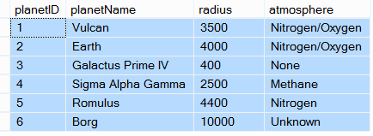

-- 2. List the name, crew size, and ship class for every starship.

SELECT starshipName, crewSize, shipClass FROM Starship;

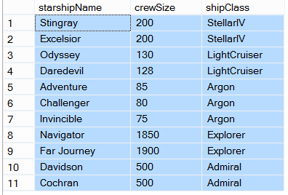

-- 3. What is the name of starship number 501?

SELECT starshipName FROM starship

WHERE starshipID = 501;



-- 4. Show all Starships launched after stardate 21500, sorted by shipClass and name.

SELECT starshipName, crewSize, shipClass, launchStarDate FROM Starship

WHERE launchStarDate > 21500

ORDER BY shipClass, starshipName;

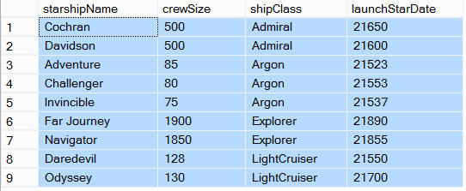

-- 5. Show all Starships except those in the 'Argon' class, sorted by launchStardate.

SELECT * FROM Starship

WHERE NOT (shipClass = 'Argon')

ORDER BY launchStardate;

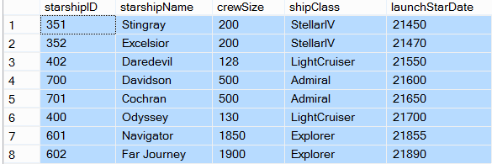

-- 6. Show all planets with a radius ranging from 2000 to 4000 kilometers, sorted from largest to smallest.

SELECT * from Planet

WHERE radius >= 2000 AND radius <= 4000

ORDER BY radius DESC;

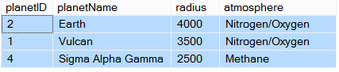

-- 7. Show all PlanetVisits where the length of the visit >= 4 stardates.

SELECT planetID, starshipID, departureStarDate - arrivalStarDate AS visitLength FROM PlanetVisit

WHERE (departureStarDate - arrivalStarDate) >= 4;

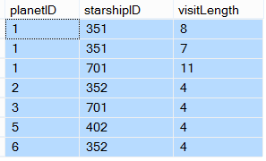

-- 8. List the planet, starship, and length of stay for each planet visit.

SELECT planetName, starshipName, departureStarDate - arrivalStarDate AS lengthOfStay

FROM PlanetVisit v INNER JOIN Planet p

ON v.planetID = p.planetID

INNER JOIN Starship s

ON s.starshipID = v.starshipID;

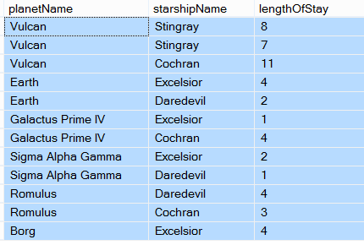

-- 9. Show all PlanetVisits to planets with planetIDs 1, 2, and 5, sorted by planetID and starshipID.

SELECT * FROM PlanetVisit

WHERE planetID IN ('1', '2', '5')

ORDER BY planetID, starshipID;

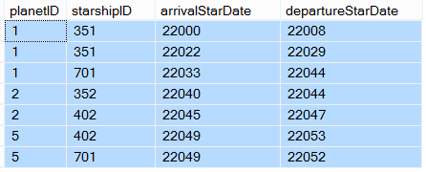

-- 10. Show the average crew size for all starships in each shipClass. The result table should have two columns: 'shipClass' and 'Average Crew'.

SELECT shipClass, AVG (crewSize) as Average_Crew

FROM Starship

GROUP BY shipClass;

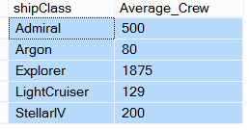

-- 11. For each Planet, show the number of visits made by all starships. Your result table should have two columns: 'planetID' and 'Num Visits'.

SELECT planetID, COUNT (planetID) AS 'Num Visits'

FROM PlanetVisit

GROUP BY planetID;

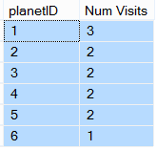

-- 12. Show all Starships whose name has an 'a' as the 2nd character (For example, 'Navigator').

SELECT starshipName FROM Starship

WHERE starshipName LIKE '_a%';

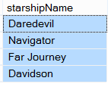

-- 13. List the details of each planet visit along with the crewsize of the starship making the visit.

SELECT p.planetID, p.planetName, s.starshipID, s.starshipName, v.arrivalStarDate, v.departureStarDate, s.crewSize

FROM planetVisit v INNER JOIN Starship s

ON v.starshipID = s.starshipID

INNER JOIN Planet p

ON v.planetID = p.planetID;

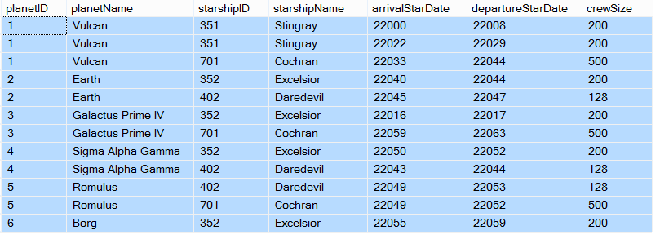

-- 14. Create a table ‘Moon’ with the following attributes: MoonID, name, PlanetID, radius.

CREATE TABLE Moon

(MoonID SMALLINT NOT NULL,

name VARCHAR (30) NOT NULL,

PlanetID SMALLINT NOT NULL,

radius SMALLINT NOT NULL

CONSTRAINT pk_MoonID PRIMARY KEY (MoonID)

);

-- 15. Add a constraint to the ‘Moon’ table making planetId a foreign key to the Planet table.

ALTER TABLE Moon

ADD CONSTRAINT fk_Moon_planetID FOREIGN KEY (planetID) REFERENCES Planet (planetID);

-- 16. Insert 5 rows of data into the ‘Moon’ table.

INSERT INTO Moon (MoonID, name, PlanetID, radius) VALUES ('1', 'Venus', '1', '1000');

INSERT INTO Moon (MoonID, name, PlanetID, radius) VALUES ('2', 'Sun', '2', '1500');

INSERT INTO Moon (MoonID, name, PlanetID, radius) VALUES ('3', 'Pluto', '3', '800');

INSERT INTO Moon (MoonID, name, PlanetID, radius) VALUES ('4', 'Zeus', '4', '1000');

INSERT INTO Moon (MoonID, name, PlanetID, radius) VALUES ('5', 'Grayzone', '5', '700');

-- 17. Delete the ‘Moon’ table.

DROP TABLE Moon;

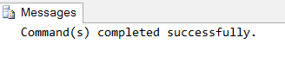

-- 18. Union the name of every starship in the ‘Admiral’ class with the name of every planet with a radius > 3000.

SELECT starshipName AS StarshipPlanetUnion

FROM Starship s

WHERE s.shipClass = 'Admiral'

UNION

SELECT planetName

FROM Planet p

WHERE p.radius > 3000;

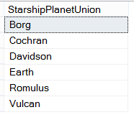

-- 19. Find the name, crewsize, and shipclass of every starship whose crewsize is larger then the crewsize of every starship of shipclass ‘LightCruiser’.

SELECT starshipName, crewSize, shipClass

FROM Starship

WHERE crewSize > (SELECT MAX (crewSize) max_crewSize FROM Starship WHERE shipClass = 'LightCruiser');

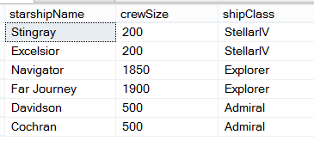

-- 20. Change the name of starship 351 to ‘Atlas’.

UPDATE Starship

SET starshipName = 'Atlas'

WHERE starshipID = '351';

